Project Design Phase-II Technology Stack (Architecture & Stack)

|  |  |
| --- | --- |
| Date | 12 November 2022 |
| Team ID | PNT2022TMID07793 |
| Project Name | REAL TIME RIVER WATER QUALITY MONITORING AND CONTROL SYSTEM |
| Maximum Marks | 4 Marks |

Technical Architecture:

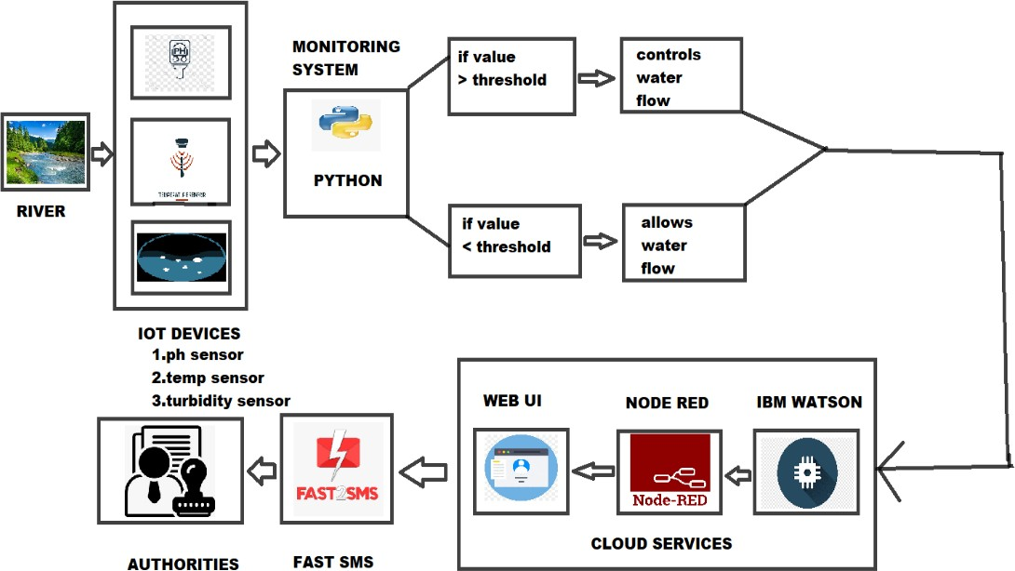

Table-1 : Components & Technologies:

|  |  |  |  |
| --- | --- | --- | --- |
| **S. No** | **Component** | **Description** | **Technology** |
| 1. | User Interface | The UI is the point of human computer interaction and communication in a device | WEB UI. |
| 2. | Application Logic-1 | Logic for a process in the software application | Python. |
| 3. | Application Logic-2 | Logic for a process in the sensor application | IBM Watson STT service. |
| 4. | Application Logic-3 | Logic for checking the accurate water quality | Quality monitoring system. |
| 5. | Database | The PH, temperature, turbidity values are stored. | MySQL, NoSQL. |
| 6. | Cloud Database | A cloud database helps to store, organize and manage data. | IBM Cloudant |
| 7. | File Storage | File storage requirements | IBM Cloudant DB Storage |
| 8. | External API-1 | It is used to get depth data and climate, environment weather for analysis | IBM Weather API. |
| 9. | Machine Learning Model | It allows the user to feed a computer algorithm an immune amount of data and have the computer  analyse the make data-driven recommendation | Recognize model. |
| 10. | Infrastructure (Server / Cloud) | Application Deployment on IBM cloud | Node RED. |

Table-2: Application Characteristics:

|  |  |  |  |
| --- | --- | --- | --- |
| **S.No** | **Characteristics** | **Description** | **Technology** |
| 1. | Open-Source Frameworks | Online software tools | Tinkercad, wokwi, etc. |
| 2. | Security Implementations | The system uses cloud storage for security purpose and backup the data any time | IBM Cloud services. |
| 3. | Scalable Architecture | This project is scalable because it covers a particular zone | IBM Watson IOT. |
| 4. | Availability | The system is availability for 24/7 for the regular supply of quality water | Rechargeable sensors. |
| 5. | Performance | This system works in low power and highly efficient | IOT, Node RED, WIFI module sensors. |